**Task Report:** Snort as an IDS, and IPS Comprehensive Study

**Prepared by:** Manasseh Mutugi

**Position:** SOC Analyst

**Date:** March 2025

**Department:** Cybersecurity Research

**Abstract:**

The Snort module on TryHackMe provides an immersive and hands-on learning experience for cybersecurity enthusiasts and professionals aiming to master the art of intrusion detection and prevention. Snort, an open-source network intrusion detection and prevention system (IDS/IPS), is widely used in the industry to monitor network traffic and identify potential threats in real-time. This module on TryHackMe offers a comprehensive guide to understanding, configuring, and deploying Snort in various network environments.

**What is Snort?**

Snort is an open-source Intrusion Detection System (IDS) and Intrusion Prevention System (IPS) developed by Martin Roesch in 1998. It is widely used for real-time traffic analysis and packet logging, helping security analysts detect and prevent network-based attacks.

**Importance in Network Security**

Snort plays a crucial role in cybersecurity operations, especially in Security Operations Centers (SOCs) and enterprise environments.

Why Snort is Important?

| Security Aspect | How Snort Helps |
| --- | --- |
| Intrusion Detection | Identifies known attacks using signature-based detection. |
| Intrusion Prevention | Blocks malicious traffic before it reaches the target. |
| Traffic Monitoring | Analyzes network traffic for suspicious behavior. |
| Compliance | Helps organizations meet security standards (PCI-DSS, HIPAA, GDPR). |
| Threat Intelligence | Continuously updated rule sets improve threat visibility. |

**Use Cases of Snorts**

* Protecting corporate networks from hackers and malware.
* Detecting reconnaissance attacks, such as port scans.
* Analyzing logs to investigate past cyber incidents.
* Monitoring network traffic in cloud and hybrid environments.

Room: **Snort** [**https://tryhackme.com/room/snort**](https://tryhackme.com/room/snort)

**Interactive Material and VM**

Navigate to the Task-Exercises folder and run the command "./.easy.sh" and write the output? **Too easy!**

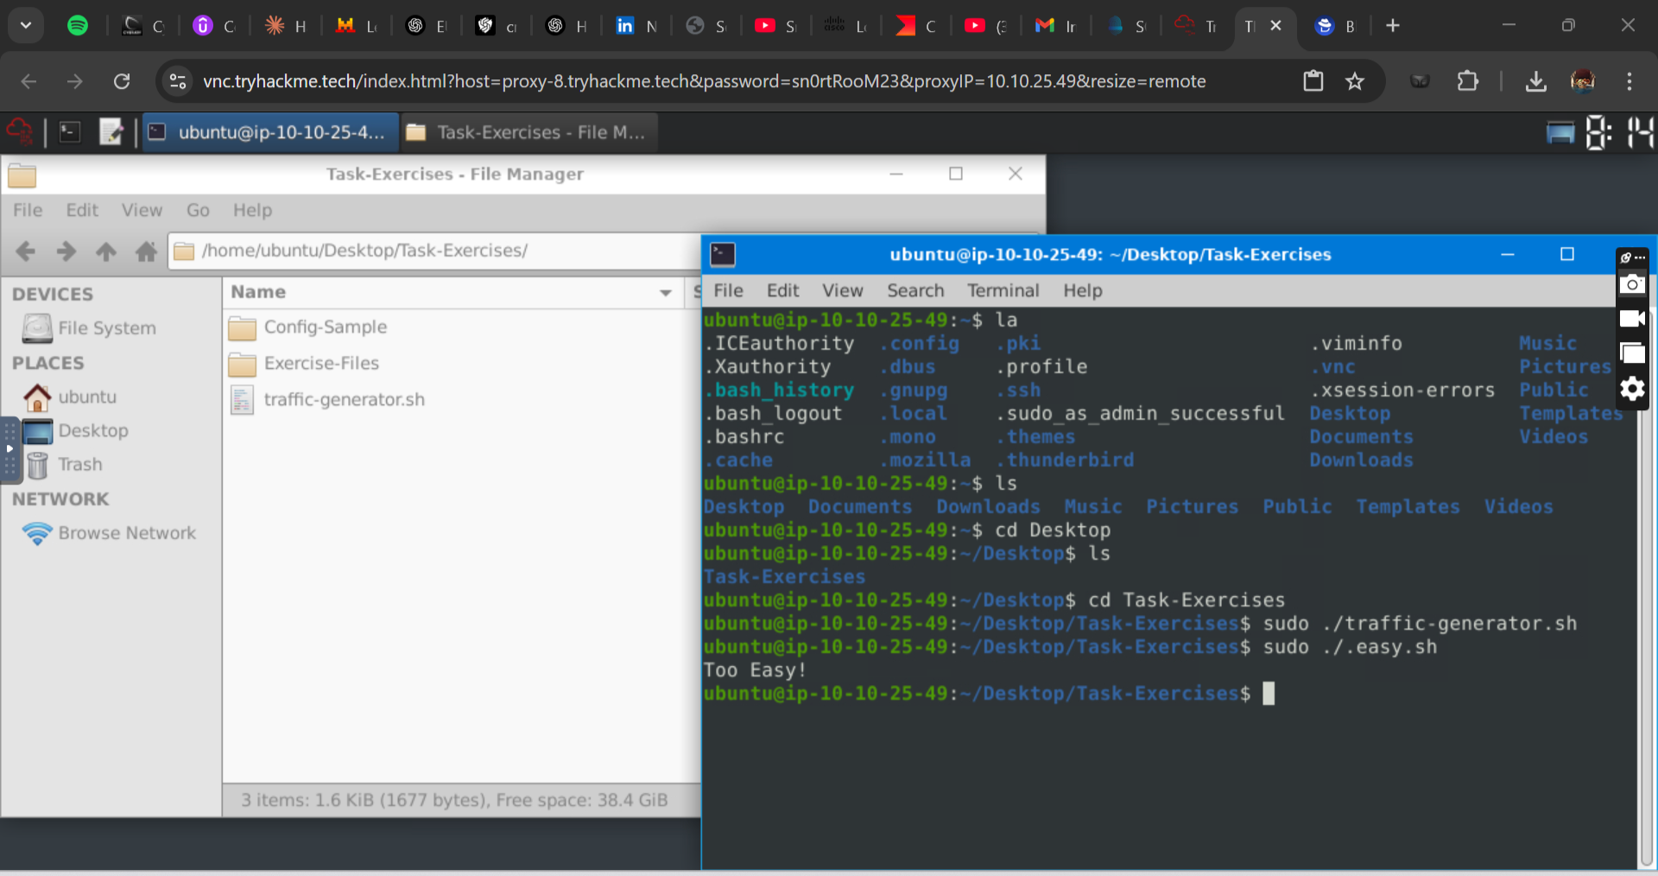

**Introduction to IDS/IPS**

Run the Snort instance and check the build number? **149**

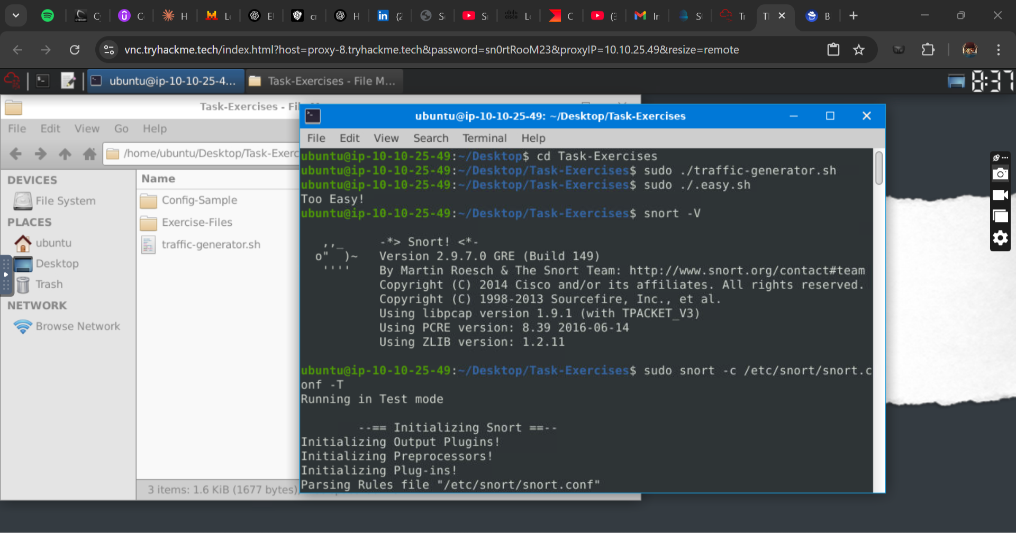

Test the current instance with "/etc/snort/snort.conf" file and check how many rules are loaded with the current build. **4151**

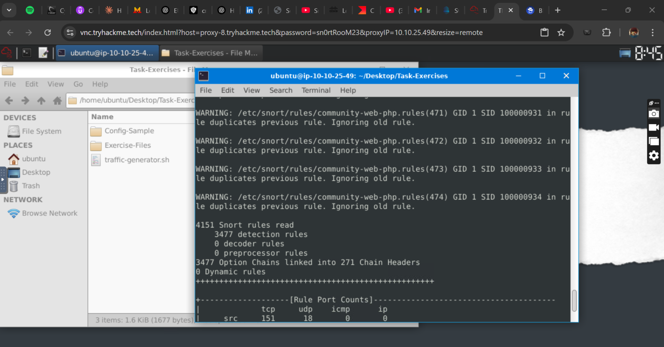

Test the current instance with "/etc/snort/snortv2.conf" file and check how many rules are loaded with the current build. **1**

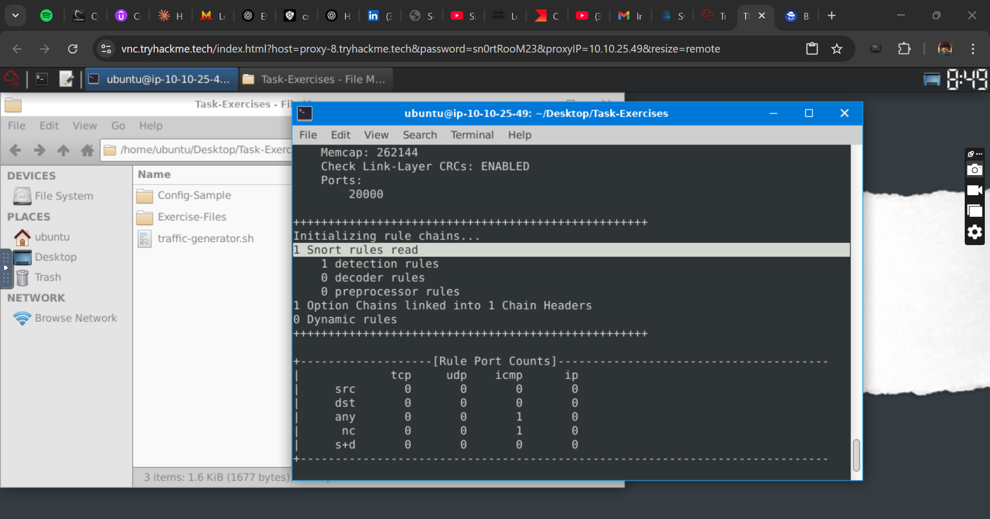

**Operation Mode 2: Packet Logger Mode**

Now, you should have the logs in the current directory. Navigate to folder "145.254.160.237". What is the source port used to connect port 53? **3009**

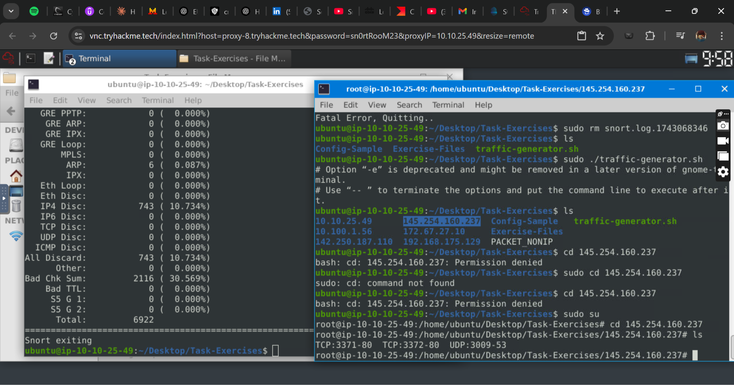

Read the snort.log file with Snort; what is the IP ID of the 10th packet? **49313** s

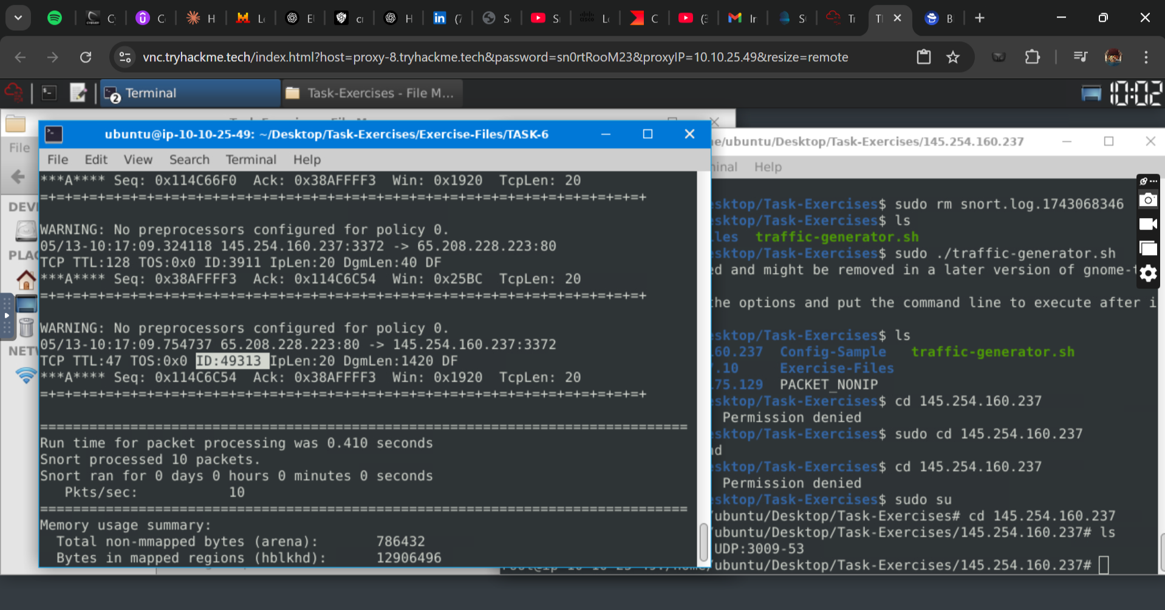

Read the "snort.log.1640048004" file with Snort; what is the referer of the 4th packet? **http://www.ethereal.com/development.html**

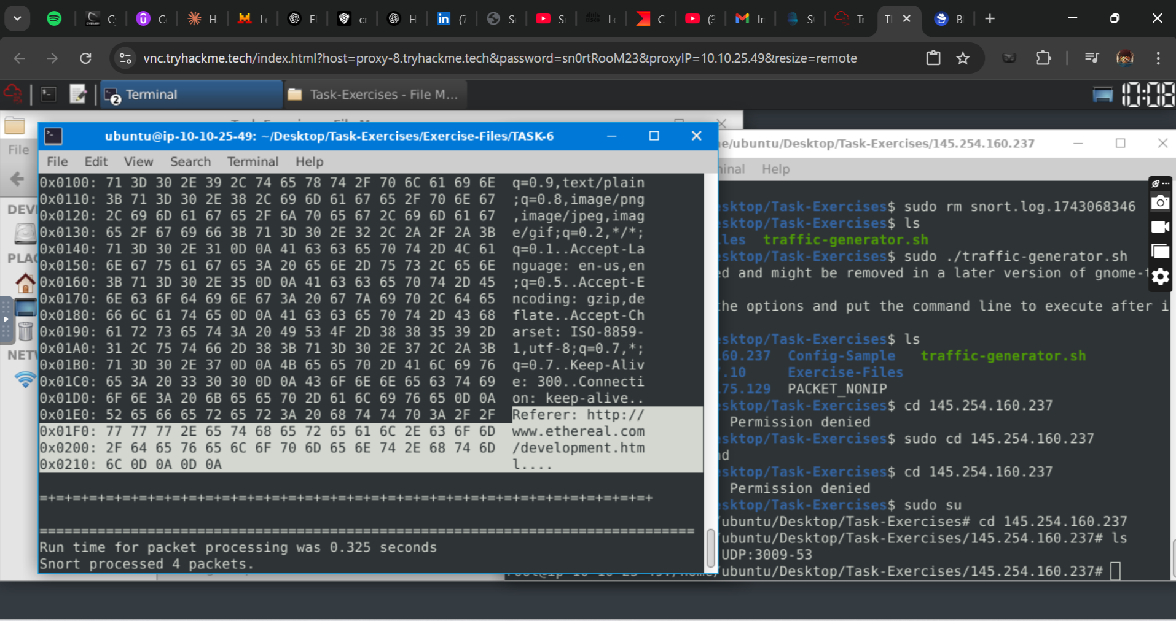

Read the "snort.log.1640048004" file with Snort; what is the Ack number of the 8th packet? **0x38AFFFF3** *(snort -r snort.log.1640048004 -n 10 –X)*

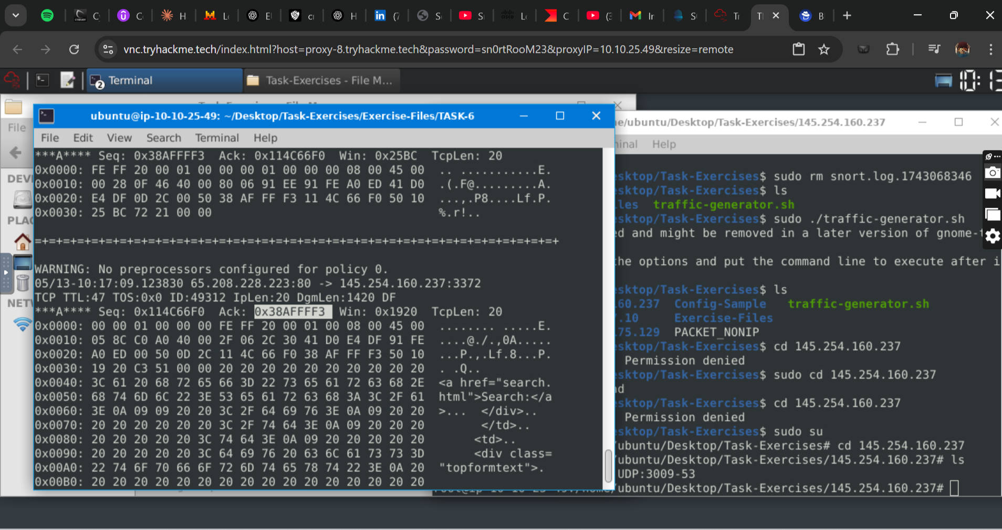

Read the "snort.log.1640048004" file with Snort; what is the number of the "TCP port 80" packets? **41**

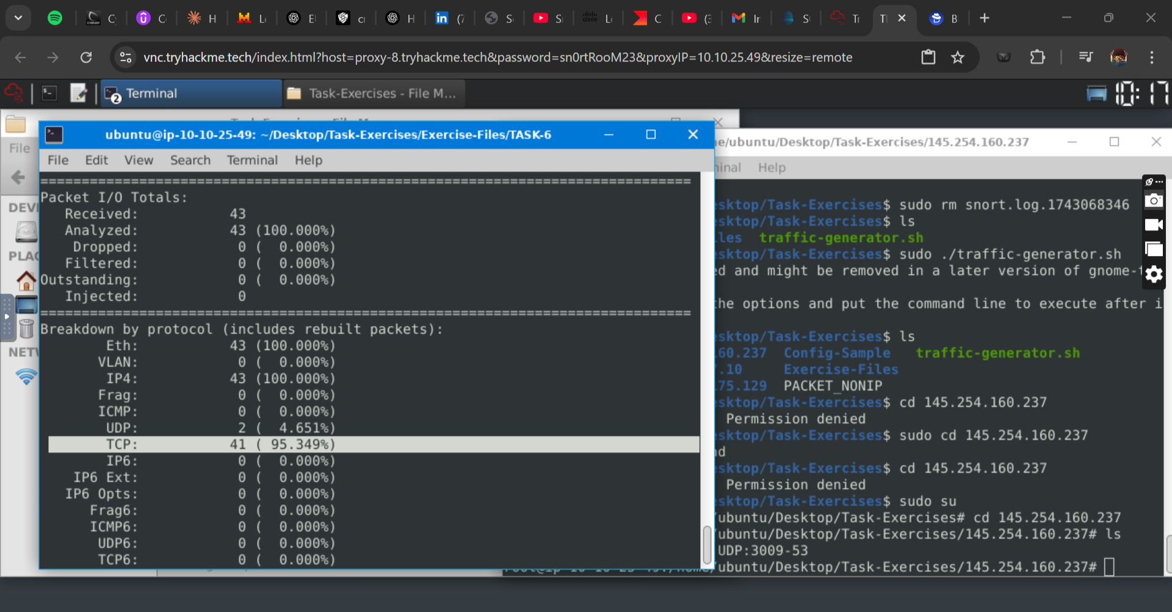

**Operation Mode 3: IDS/IPS**

What is the number of the detected HTTP GET methods? **2** s

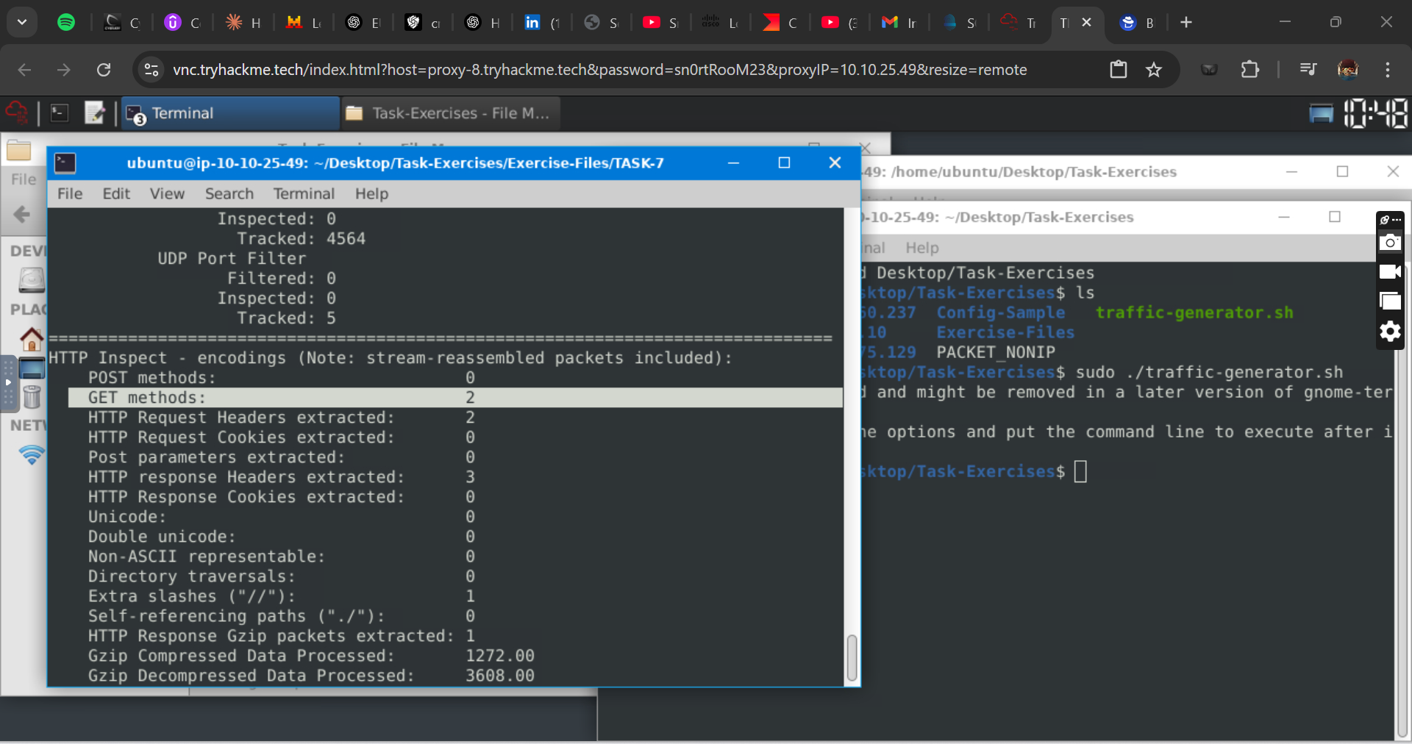

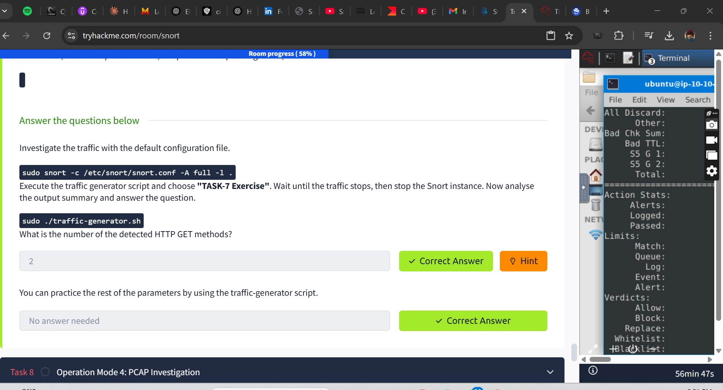

**Operation Mode 4: PCAP Investigation**

What is the number of the generated alerts? **170**

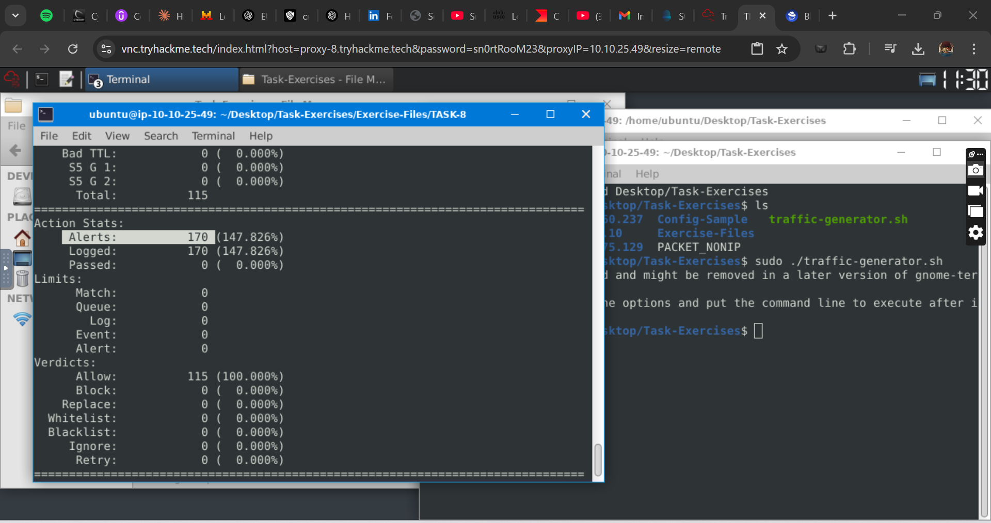

Keep reading the output. How many TCP Segments are Queued**? 18**

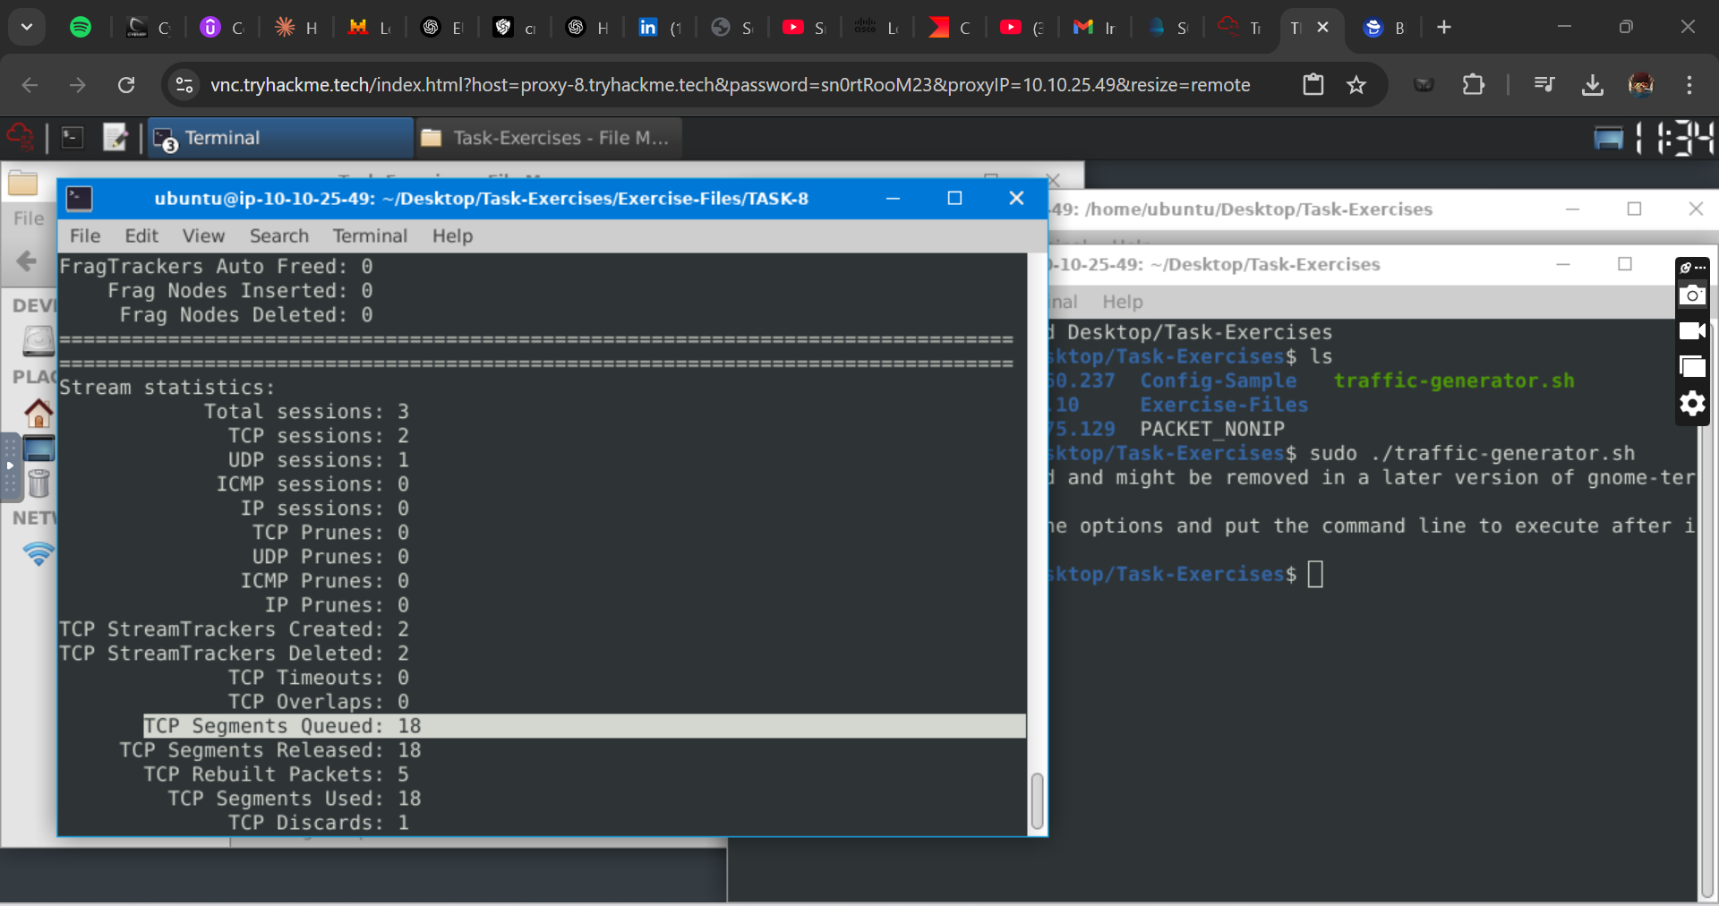

Keep reading the output.How many "HTTP response headers" were extracted? **3**

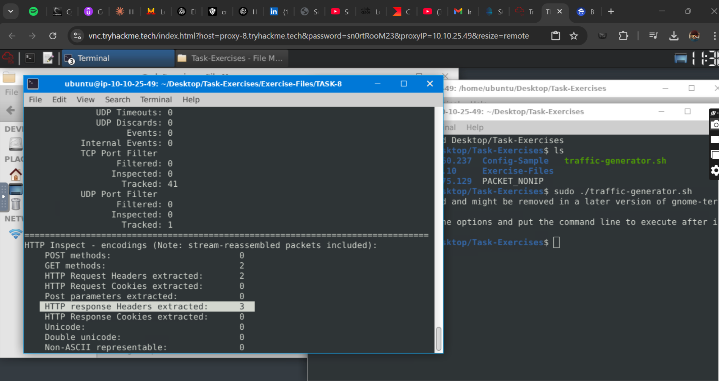

Investigate the mx-1.pcap file with the second configuration file.

*sudo snort -c /etc/snort/snortv2.conf -A full -l . -r mx-1.pcap*

What is the number of the generated alerts? **68**

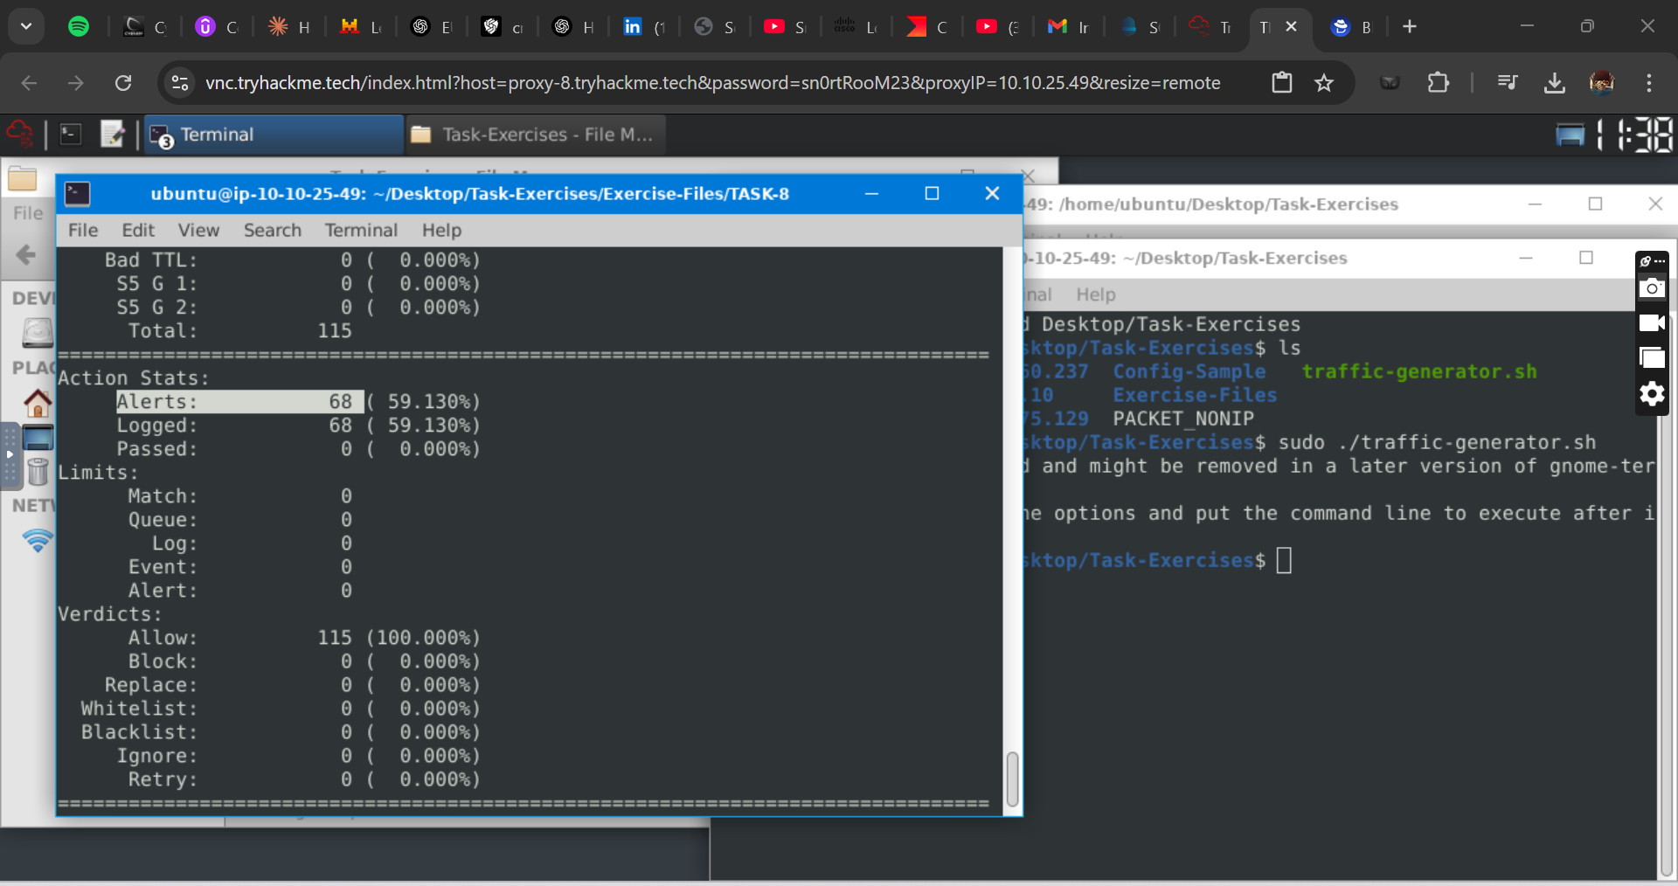

Investigate the **mx-2.pcap** file with the default configuration file.

*sudo snort -c /etc/snort/snort.conf -A full -l . -r mx-2.pcap*

What is the number of the generated alerts? **340**

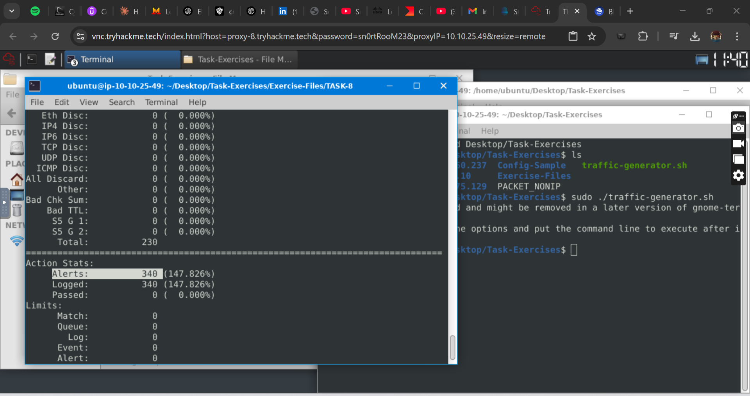

Keep reading the output. What is the number of the detected TCP packets? **82**

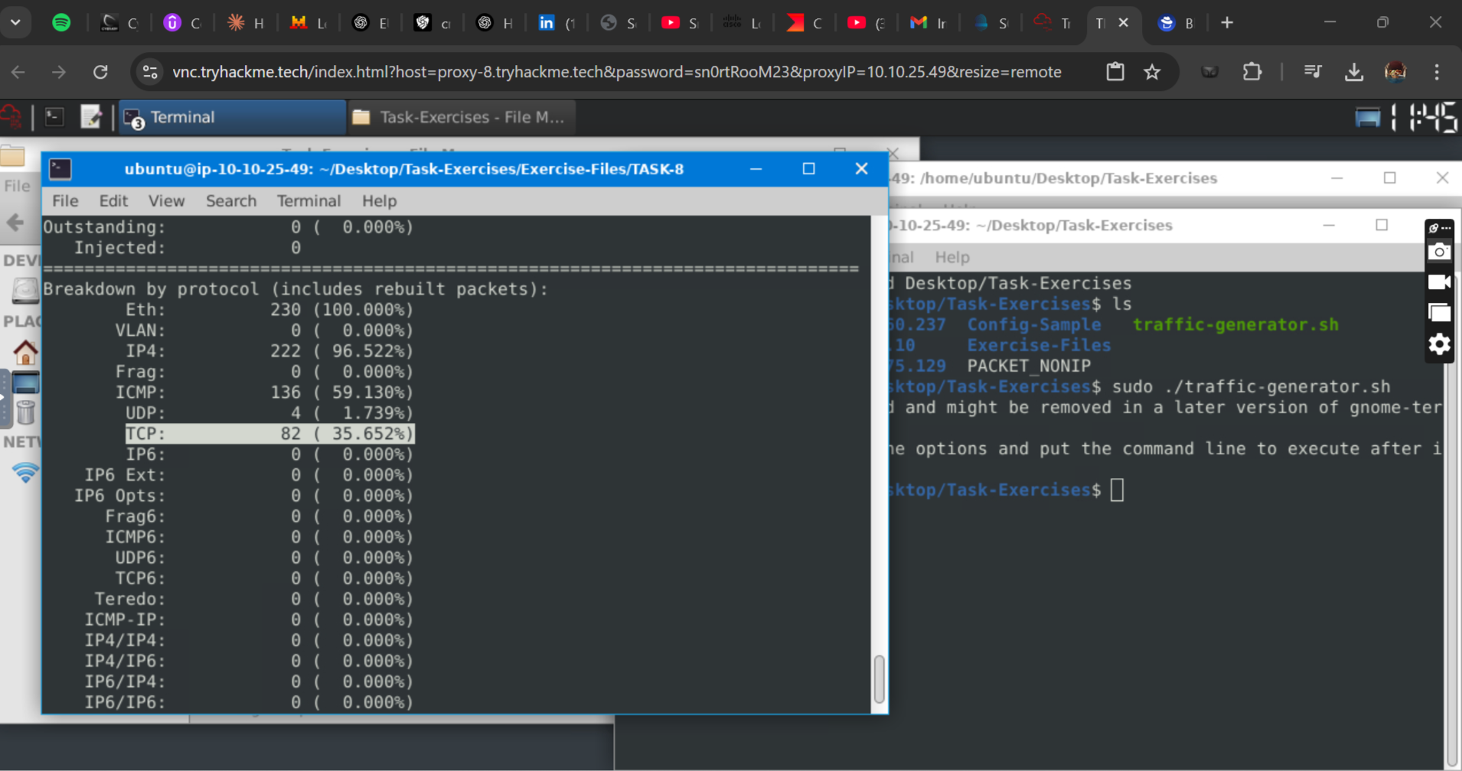

Investigate the mx-2.pcap and mx-3.pcap files with the default configuration file.

*sudo snort -c /etc/snort/snort.conf -A full -l . --pcap-list="mx-2.pcap mx-3.pcap"*

What is the number of the generated alerts? **1020**

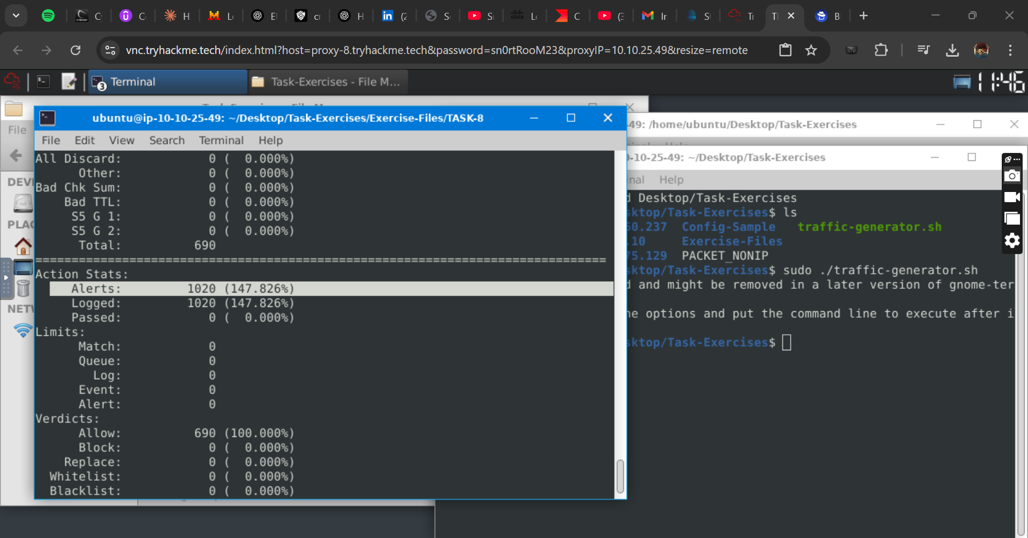

**Snort Rule Structure**

Use "task9.pcap". Write a rule to filter IP ID "35369" and run it against the given pcap file. What is the request name of the detected packet? You may use this command: "snort -c local.rules -A full -l . -r task9.pcap"  **TIMESTAMP REQUEST**

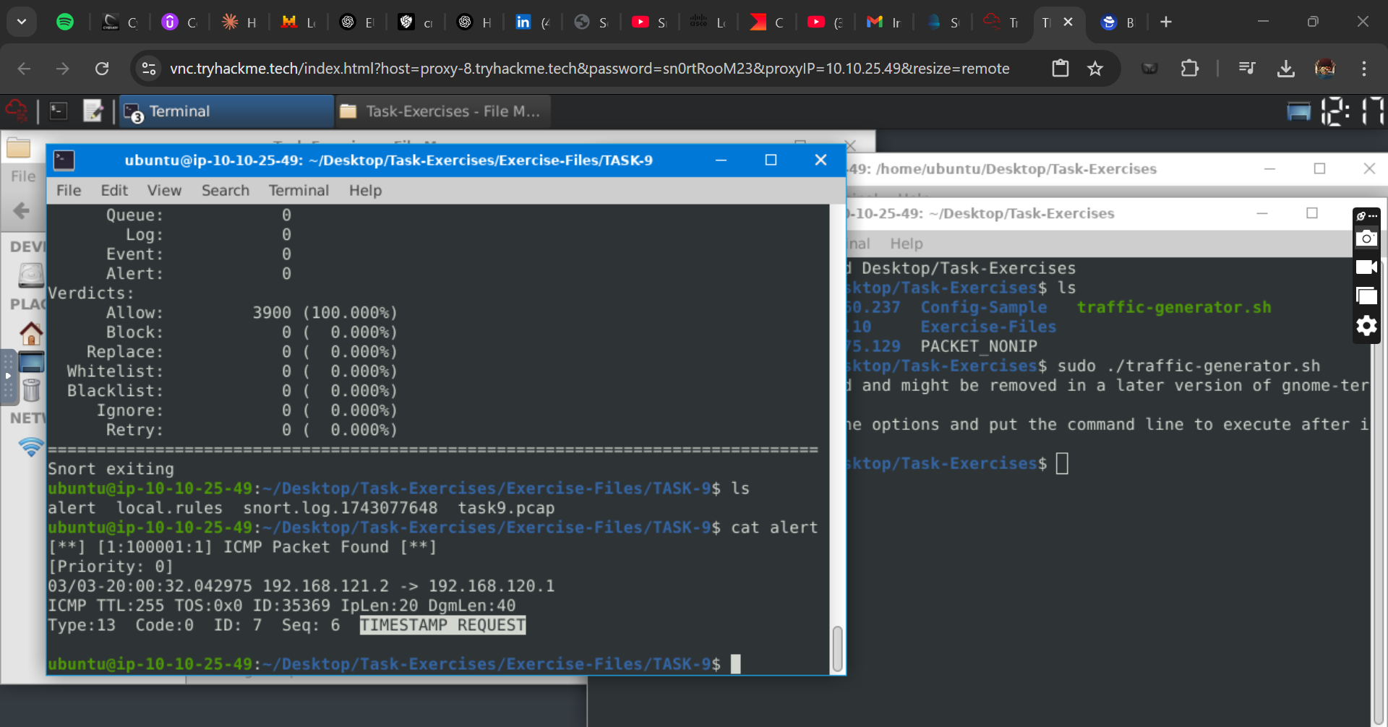Clear the previous alert file and comment out the old rules. Write a rule to filter packets with Push-Ack flags and run it against the given pcap file. What is the number of detected packets? **216** 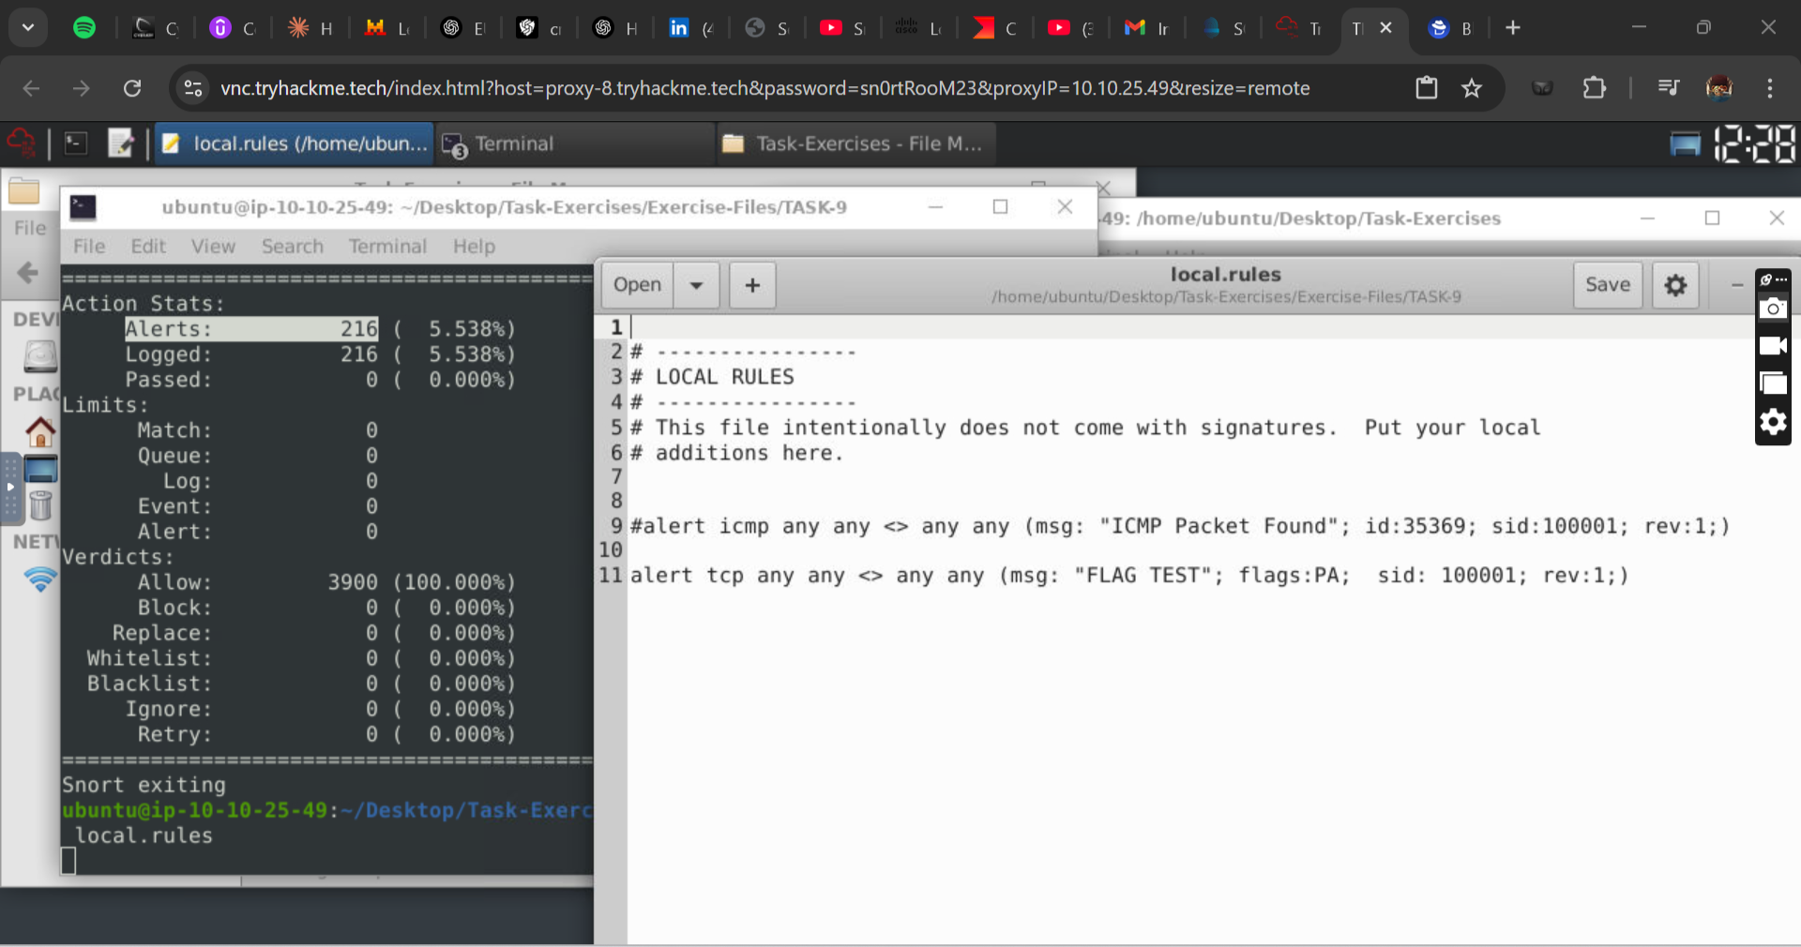

Clear the previous alert file and comment out the old rules. Create a rule to filter UDP packets with the same source and destination IP and run it against the given pcap file. What is the number of packets that show the same source and destination address? **7**

